Traffic and parking Impact statement for additional at a Childcare Centre

***16 DUDLEY STREET in PUNCHBOWL***

Traffic and Parking Impact Report

Prepared for: Ultra Design and Engineering

N1916227A (Version 1a)

March 2025

# Introduction

ML Traffic Engineers was commissioned by Ultra Design and Engineering to undertake a traffic and parking impact statement of a proposed increase in children of an approved childcare centre at 16 Dudley Street in Punchbowl (not yet built). The approved childcare centre is for 60 children. The proposal is for an additional eight additional children.

The site is a currently a house

This report focuses on the proposed childcare centre and changes in car usage and car park utilisation of the proposed childcare centre.

In the course of preparing this assessment, the subject site and its environs have been inspected, plans of the development examined.

# background and existing conditions

## Location and Land Use

The subject site is located on the eastern side of Dudley Street at property No. 16 (legally known as Lot 39 of DP5701), within the suburb of Punchbowl. The site has a frontage of 15.24 metres to Dudley Street from the west.

Figures 1 and 2 show the location of the development site from an aerial and street map perspective respectively.

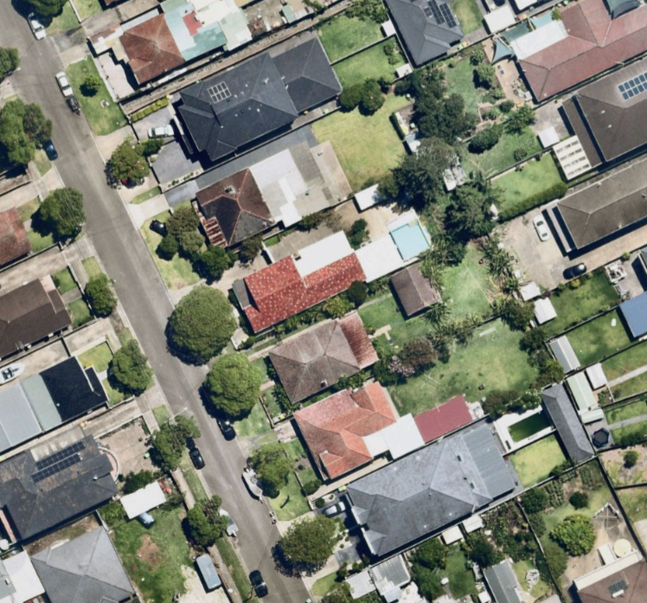

Proposed Residential Development

Figure 1: Location of the Subject Site on Aerial

Proposed Childcare Centre

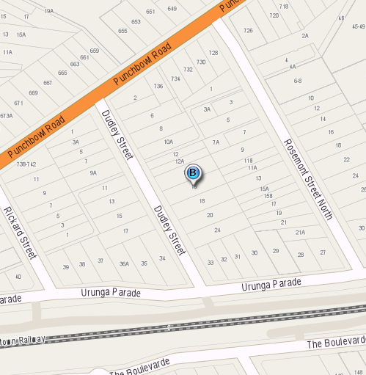

Figure 2: Street Map of the Location of the Development Site

## Road Network

This section describes the roads near the proposed childcare centre.

Dudley Street has a two-way undivided carriageway with a width between kerbs of approximately 9 metres. This carriageway generally provides one travel lane per direction, plus a kerbside parking lane on both sides of the road. At present, unrestricted parking is permitted on both sides of Dudley Street, with the exception of the signposted ‘No Stopping’ at its intersection with Punchbowl Road.

The legal speed limit on Dudley Street is 50km/h. Dudley Street intersects with Punchbowl Road and is controlled by a T-priority, given to traffic travelling along Punchbowl Road. Dudley Street also intersects with Urunga Parade and is controlled by a T-priority, given to traffic travelling along Urunga Parade.

## Public Transport within Punchbowl

The subject site has good access to public transport services in the form of trains and buses. The site is located approximately 450 metres from Punchbowl Railway Station and 1.1 km from Wiley Park Railway Station.

Frequent bus services operate along Dudley Street, The Boulevarde, Hillcrest Street, Rose Street, Acacia Avenue, Gowrie Avenue, Carrisbrook Avenue, Canterbury Road and Cullens Road in close proximity to the subject site (i.e. bus routes 940, 941, 944, N40, S14, 10T3, 33T3 and 34T3).

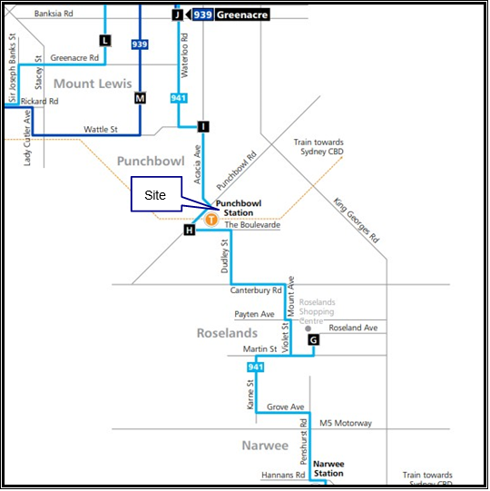

Figure 3: Bus services near the subject site (Bus no. 941)

## Existing Traffic Volumes

The following Figures present the existing traffic volumes for the weekday peak hours as presented in the in the original Development Application submission at the priority intersection of Punchbowl Road with Dudley Street



Figure 4A: Weekday AM Peak Traffic Volumes



Figure 4B: Weekday AM Peak Traffic Volumes

## Intersection Description

As part of the traffic assessment, two intersections are assessed:

* Priority Intersection of Punchbowl Road with Dudley Street

External traffic travelling to and from the development site will need to travel through one of the above intersections.

The priority intersection of Punchbowl Road with Dudley Street is a three-leg intersection with all turn movements permitted. Drivers travelling on Dudley Street must give way to traffic on Rossi Street. Figure 5 presents the layout of this intersection using SIDRA – an industry standard intersection software.

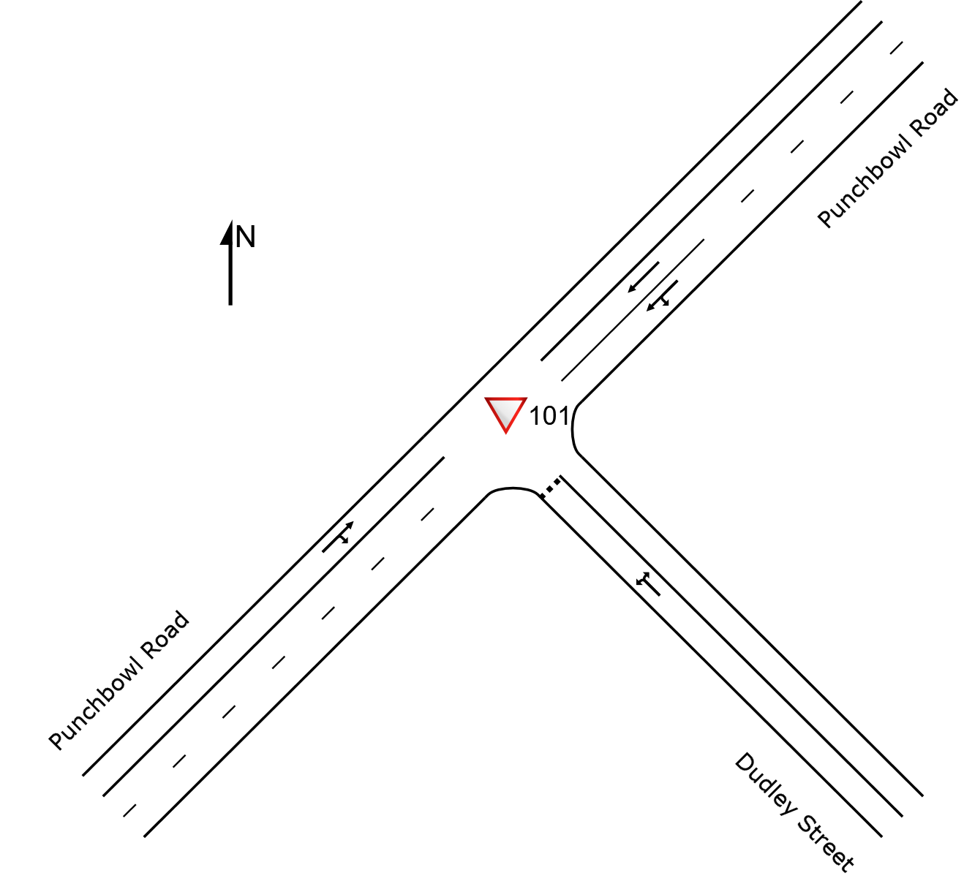

**Figure 4A: The priority intersection of Punchbowl Road with Dudley Street (SIDRA)**

## Intersection Assessment with Existing Traffic

An intersection assessment has been undertaken for the:

* Priority Intersection of Punchbowl Road with Dudley Street

The existing intersection operating performance was assessed using the SIDRA software package (version 9.1) to determine the Degree of Saturation (DS), Average Delay (AVD in seconds) and Level of Service (LoS) at each intersection. The SIDRA program provides Level of Service Criteria Tables for various intersection types. The key indicator of intersection performance is Level of Service, where results are placed on a continuum from ‘A’ to ‘F’, as shown in Table 1.

|  |  |  |
| --- | --- | --- |
| LoS | Traffic Signal / Roundabout | Give Way / Stop Sign / T-Junction control |
| A | Good operation | Good operation |
| B | Good with acceptable delays and spare capacity | Acceptable delays and spare capacity |
| C | Satisfactory | Satisfactory, but accident study required |
| D | Operating near capacity | Near capacity & accident study required |
| E | At capacity, at signals incidents will cause excessive delays. | At capacity, requires other control mode |
| F | Unsatisfactory and requires additional capacity, Roundabouts require other control mode | At capacity, requires other control mode |

Table 1: Intersection Level of Service

The Average Vehicle Delay (AVD) provides a measure of the operational performance of an intersection as indicated below, which relates AVD to LOS. The AVD’s should be taken as a guide only as longer delays could be tolerated in some locations (i.e., inner city conditions) and on some roads (i.e., minor side street intersecting with a major arterial route). For traffic signals, the average delay over all movements should be taken. For roundabouts and priority control intersections (sign control) the critical movement for level of service assessment should be that movement with the highest average delay.

|  |  |
| --- | --- |
| LoS | Average Delay per Vehicles (seconds/vehicle) |
| A | Less than 14 |
| B | 15 to 28 |
| C | 29 to 42 |
| D | 43 to 56 |
| E | 57 to 70 |
| F | >70 |

Table 2: Intersection Average Delay (AVD)

The degree of saturation (DS) is another measure of the operational performance of individual intersections. For intersections controlled by traffic signals both queue length and delay increase rapidly as DS approaches 1. It is usual to attempt to keep DS to less than 0.9. Degrees of Saturation in the order of 0.7 generally represent satisfactory intersection operation. When DS exceed 0.9 queues can be anticipated.

The results of the intersection analysis are as follows:

|  |  |  |
| --- | --- | --- |
| Intersection/  Performance criteria | AM Peak Hour Existing | PM Peak Hour Existing |
| **Punchbowl Rd/Dudley St**  *LoS*  *AVD*  *DS* | N/A: (Worst C)  1  0.497 | N/A: (Worst B)  0.1  0.4.47 |

Table 3: Existing Intersection Performances

As presented in Table 3, the intersection is currently operating in excellent condition with spare capacity to accommodate additional traffic.

## Conclusions on the Existing Conditions

The childcare site has good access to public transport.

The assessed intersection performs well in the AM and PM peal hour with spare capacity for additional trips.

# Proposed childcare centre

The proposed development is for the demolition of the existing residential dwelling located at 16 Dudley Street, Punchbowl and the construction of a childcare centre with on-site basement parking, accommodating 68 children places.

The details of the childcare centre are as follows:

* 10 children places between the ages of 2 to 3 years old (2 staff members);
* 58 children places between the ages of 3 to 6 years old (6 staff members).
* A total of eleven (11) on-site car parking, with 4 car spaces for staff parking and 5
* visitor car parking spaces for drop-off and pick-up of children (including 1 accessible parking space & an adjacent shared area), in addition to 2 bicycle storage spaces, in basement level.
* There will be a maximum of seven (8) staff members on-site at any given time. The proposed hours of operation of the centre will be from 7.00am to 6.00pm on weekdays only.

# parking considerations

## Canterbury-Bankstown Council Development Control Plan 2023

Canterbury-Bankstown Council’s *Development Control Plan 2023, Section B1.3.1*, requires on-site parking for childcare centres to be provided at a minimum rate of:

* 1 car space per 4 children

The additional eight children require two additional car space in addition to the approved nine car spaces. A total of eleven car spaces are provided.

# vehicle Traffic Impact Considerations

## Traffic Generation

The *Guide to Transport Impact Assessment 2024* publishescar trip rates as it applies to the proposed residential development, as follows:

* 0.9 and 0.8 trips per dwelling for the AM and PM peak hours respectively for low density residential dwelling in regional areas

Table 3 summarise the additional trip generation for the proposed childcare centre and existing two dwellings. The net trips are obtained by subtracting the trips generated by the existing development from the estimated trips generated by the proposed development. The proposed childcare centre is a low trip generator with the net trips presented in Table 4.

|  |  |  |  |
| --- | --- | --- | --- |
|  | Children | Trip Rate per Child | Trips |
| AM Peak hour | 8 | 0.9 | 8 |
| PM Peak hour | 0.8 | 7 |

**Table 4: Summarises the extra trip generation for the proposed** **childcare centre**

The additional eight children will generate a low number of additional trips in the weekday AM and PM peak hours

# Conclusions

Based on the considerations presented in this report, it is considered that:

***Parking***

* The proposed childcare centre complies with Council’s Development Control Plan for the number of car spaces required.
* The site has good access to public transport.

***Traffic***

* The increase in the number of children will generate a low number of additional car spaces in the weekday AM and PM peak hours and will not impact upon the nearby road network
* There are no traffic engineering reasons why a planning permit for the development at 16 Dudley Street in Punchbowl should be refused.